1. How have sales changed over time?
A Line Chart is ideal for showing trends over time. It clearly communicates sales fluctuations across months.
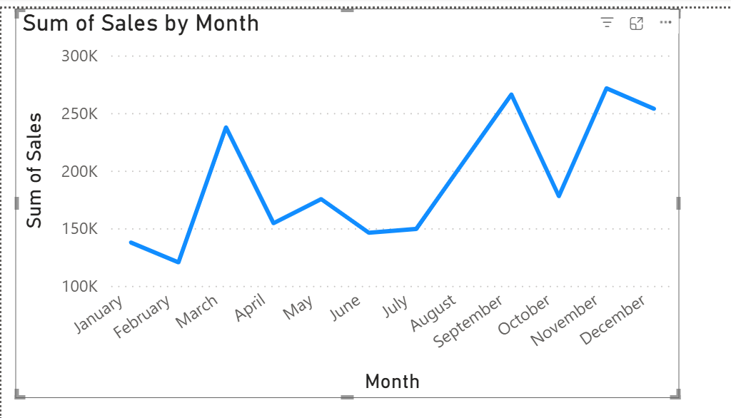

- March, September, and November show major sales peaks.
- February and November dips may indicate seasonal slowdowns.
- “Sales show strong seasonality, with demand surging in March and toward year-end. Management could investigate what drives these spikes (e.g., campaigns or holidays) and replicate them.”
- Suggest reinforcing marketing efforts in low months to smooth sales.
2. Top-Selling Products or Categories (Bar Chart)

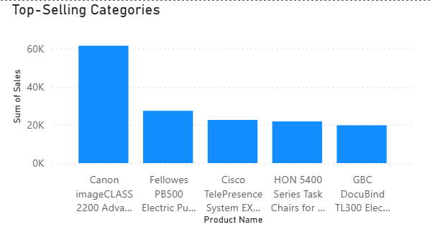

- “Canon products lead sales at over $60K — over twice the next category.”
- “Electronics and Furniture account for majority of sales — focus marketing and inventory on these high performers.”
- Canon’s sales dominance suggests it’s a key revenue driver.
- Top categories like Canon and Cisco account for 60%+ of total sales — reinforcing need for inventory focus.”

3.Who are our top customers? stacked Bar Chart (Top 10)

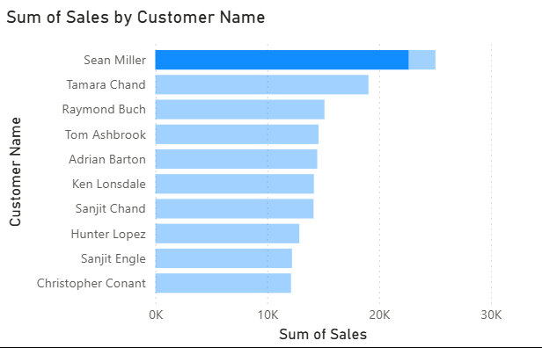

- Tamara Chand follows with strong performance (~20K), while the remaining eight customers show steady but moderate sales between 10K–15K.
- This indicates a heavy reliance on one major customer, with opportunities to grow mid-tier accounts and reduce concentration risk.
- Deepening ties with Sean Miller and Tamara Chand to maintain momentum.
- Upselling and cross-selling to mid-tier customers to diversify revenue.
- Retention and engagement initiatives for lower-tier clients to drive consistent growth.
- Sales are healthy but concentrated. Sustaining top performers while developing mid-tier customers can create a more balanced, resilient sales portfolio.

